**CASSANDRA**

**Perform the following DB operations using Cassandra.**

1.Create a keyspace by name Library



2. Create a column family by name Library-Info with attributes Stud_Id Primary Key,Counter_value of type Counter,Stud_Name, Book-Name, Book-Id,

Date_of_issue.



3. Insert the values into the table in batch



4. Display the details of the table created and increase the value of the counter

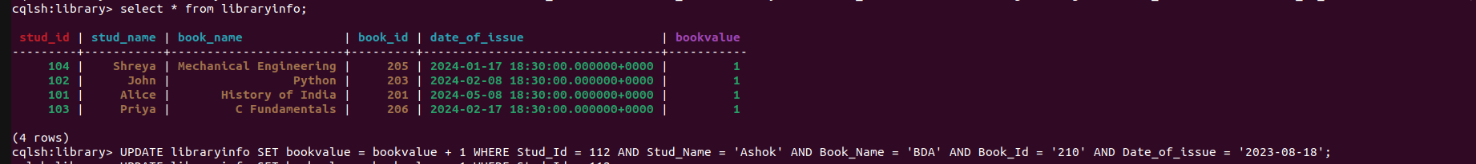

5. Write a query to show that a student with id 112 has taken a book “BDA” 2 time



6. Export the created column to a csv file



7. Import a given csv dataset from local file system into Cassandra column family

